**HOW TO INSTALL APACHE, MYSQL, PHP7.2, PYTHON-DJANGO, WEBMIN, LET’S ENCRYPT AND PHPMYADMIN ON RASPBERRY PI DESKTOP**

root@snet[~]# sudo -s

Then enter your password

root@snet[~]# sudo add-apt-repository universe

root@snet[~]# sudo add-apt-repository multiverse

**INSTALLATION OF LAMP (LINUX APACHE MYSQL PHP)**

A "LAMP" stack is a group of open source software that is typically installed together to enable a server to host dynamic websites and web apps. This term is actually an acronym which represents the Linux operating system, with the Apache web server. The site data is stored in a MySQL database, and dynamic content is processed by PHP.

**INSTALLATION OF APACHE2 SERVER**

root@snet[~]# sudo apt-get -y install apache2

**INSTALLATION OF MYSQL SERVER**

root@snet[~]# sudo apt-get -y install mysql-server mysql-client

root@snet[~]# mysql_secure_installation

***Enter password for user root: <-- Enter the MySQL root password***

***Change the password for root? (Press y|Y for Yes, any other key for No): <-- n***

***Disallow root login remotely? (Press y|Y for Yes, any other key for No) : <-- y***

***Remove test database and access to it? (Press y|Y for Yes, any other key for No) : <-- y Reload privilege tables now? (Press y|Y for Yes, any other key for No) : <-- y***

**INSTALLATION OF PHP7.2 AND ITS PACKAGES**

root@snet[~]# sudo apt install ca-certificates apt-transport-https

root@snet[~]# wget -q https://packages.sury.org/php/apt.gpg -O- | sudo apt-key add -

root@snet[~]# echo "deb https://packages.sury.org/php/ stretch main" | sudo tee /etc/apt/sources.list.d/php.list

root@snet[~]# sudo apt-get update

root@snet[~]# apt-get install php7.2 libapache2-mod-php7.2 php7.2-cgi php7.2-cli php7.2-common php7.2-curl php7.2-gd php7.2-imap php7.2-intl php7.2-json php7.2-ldap php7.2-mbstring php7.2-mysql php7.2-opcache php7.2-pspell php7.2-readline php7.2-soap php7.2-xml php7.2-zip php7.2-xmlrpc php-imagick php7.2-bcmath php-dompdf php-fpm php-mysql php7.2-memcache php7.2-memcached php7.2-stomp php7.2-xdebug php7.2-gearman php7.2-odbc php7.2-recode php7.2-tidy php7.2-xsl php7.2-enchant php7.2-geoip php7.2-interbase php7.2-mongo php7.2-ps php7.2-sybase php7.2-embed php7.2-dba php7.2-phpdbg php7.2-fpm

root@snet[~]# apt-get install build-essential apache2 php7.2 openssl perl make php7.2-gd libgd-dev libapache2-mod-php7.2 libperl-dev libssl-dev daemon wget apache2-utils unzip

root@snet[~]# sudo apt-get install unzip

root@snet[~]# apt-get install php-apcu php-apcu-bc

root@snet[~]# sudo apt install php-apcu redis-server php-redis

root@snet[~]# sudo a2enmod rewrite headers env dir mime

root@snet[~]# sudo service apache2 restart

root@snet[~]# sudo service php7.2-fpm restart

root@snet[~]# sudo apt-get update -y

root@snet[~]# sudo nano /etc/php/7.2/apache2/php.ini

***After making the change below, save the file and close out.***

***post_max_size = 1000M***

***max_input_time = 5000***

***memory_limit = 1000M***

***upload_max_file_size = 1000M***

***max_execution_time = 5000***

**CONFIGURE APACHE2 AND PHP-FPM**

root@snet[~]# sudo a2dismod php7.2 mpm_prefork

root@snet[~]# sudo a2enmod proxy_fcgi setenvif mpm_event rewrite headers env dir mime ssl http2

root@snet[~]# sudo a2enconf php7.2-fpm

root@snet[~]# sudo nano /etc/php/7.2/fpm/php.ini

***After making the change below, save the file and close out.***

***opcache.enable=1***

***opcache.enable_cli=1***

***opcache.interned_strings_buffer=8***

***opcache.max_accelerated_files=10000***

***opcache.memory_consumption=128***

***opcache.save_comments=1***

***opcache.revalidate_freq=1***

root@snet[~]# sudo systemctl restart apache2

root@snet[~]# sudo systemctl restart php7.2-fpm

**CONFIGURATION OF REDIS SERVER TO ENABLE CACHING IN UBUNTU SERVER 16.04**

root@snet[~]# sudo nano /etc/redis/redis.conf

*Now, find and change:* ***port 6379 to port 0***

*Then uncomment:* ***unixsocket /var/run/redis/redis.sock***

*unixsocketperm 700 changing permissions to 770 at the same time:* ***unixsocketperm 770***

root@snet[~]# sudo usermod -a -G redis www-data

root@snet[~]# sudo service apache2 restart

root@snet[~]# sudo service redis-server start

root@snet[~]# sudo systemctl enable redis-server

**INSTALLATION OF WEBMAIN**

Webmin is a web-based interface for system administration for Unix. Using any modern web browser, you can setup user accounts, Apache, DNS, file sharing and much more. Webmin removes the need to manually edit Unix configuration files like /etc/passwd, and lets you manage a system from the console or remotely.

Credit by [www.webmin.com/](http://www.webmin.com/)

**INSTALLATION COMMANDS**

root@snet[~]# sudo nano /etc/apt/sources.list

***Add the following line at the bottom of the file:***

root@snet[~]# deb http://download.webmin.com/download/repository sarge contrib

root@snet[~]# wget <http://www.webmin.com/jcameron-key.asc>

root@snet[~]# sudo apt-key add jcameron-key.asc

root@snet[~]# sudo apt-get update

root@snet[~]# sudo apt-get install webmin

**INSTALLATION OF PHPMYADMIN**

phpMyAdmin is one of the most popular and widely used web-based database management tools. It a free and open source PHP application that allows the users to manage single or multiple SQL database servers locally or on a remote server using a web browser (GUI).

**INSTALLATION COMMANDS**

root@snet[~]# [apt-get](https://www.server-world.info/en/command/html/apt-get.html) -y install phpmyadmin php-mbstring php-gettext

root@snet[~]# sudo systemctl restart apache2

**SECURE YOUR PHPMYADMIN**

root@snet[~]# sudo nano /etc/apache2/conf-available/phpmyadmin.conf

To Configure Apache‘s .htaccess files

We need to add an AllowOverride All **Then find the line where there is**

<Directory /usr/share/phpmyadmin>

Options FollowSymLinks

DirectoryIndex index.php

AllowOverride All

root@snet[~]# sudo systemctl restart apache2

root@snet[~]# sudo nano /usr/share/phpmyadmin/.htaccess

*Add the following information*

**AuthType Basic**

**AuthName "Restricted Files"**

**AuthUserFile /etc/phpmyadmin/.htpasswd**

**Require valid-user**

root@snet[~]# sudo apt-get install apache2-utils

**ADDING A USER TO THE PHPMYADMIN AUTHENTICATION**

root@snet[~]# sudo htpasswd -c /etc/phpmyadmin/.htpasswd snet

**Adding Another User**

root@snet[~]# sudo htpasswd /etc/phpmyadmin/.htpasswd stepehen

**HOW TO FIX PHPMYADMIN ERRORS WITH PHP7.2**

Firstly, backup sql.lib.php before editing.

root@snet[~]# sudo cp /usr/share/phpmyadmin/libraries/sql.lib.php /usr/share/phpmyadmin/libraries/sql.lib.php.bak

root@snet[~]# sudo nano /usr/share/phpmyadmin/libraries/sql.lib.php

Press CTRL + W and search for (count($analyzed_sql_results['select_expr'] == 1)

Replace it with ((count($analyzed_sql_results['select_expr']) == 1)

Save file and exit. (Press CTRL + X, press Y and then press ENTER)

Backup plugin_interface.lib.php

root@snet[~]# sudo cp /usr/share/phpmyadmin/libraries/plugin_interface.lib.php /usr/share/phpmyadmin/libraries/plugin_interface.lib.php.bak

root@snet[~]# sudo nano /usr/share/phpmyadmin/libraries/plugin_interface.lib.php

Press CTRL + W and search for

if ($options != null && count($options) > 0) {

Replace with

if ($options != null) {

Save file and exit. (Press CTRL + X, press Y and then press ENTER)

**CREATING OF DATABASE FOR OWNCLOUD SERVER**

root@snet[~]# mysql -u root -p

root@snet[~]# CREATE DATABASE owncloud;

root@snet[~]# GRANT ALL ON owncloud.* to 'owncloud'@'localhost' IDENTIFIED BY 'stephen';

root@snet[~]# FLUSH PRIVILEGES;

root@snet[~]# exit

**OR**

Navigate to phpmyadmin by [http://server’s](http://server's) name or IP/phpmyadmin and create database name called “**owncloud**” and click on create that’s all. Very easier than using the console or above. 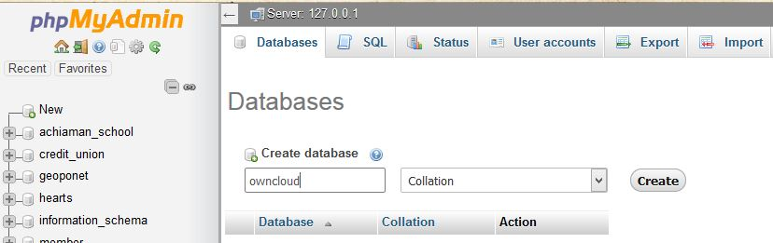

**CONFIGURING VIRTUAL HOST USING WEBMIN CONTROL PANEL**

Let's login to webmin.

Access the webmin control panel using http://IP:10000

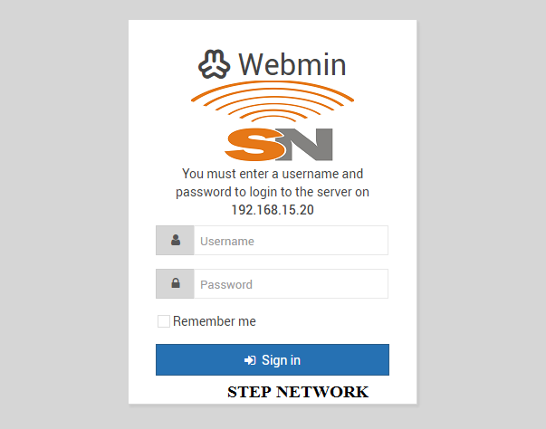

Create the folder where the site files need to be stored. You can create a folder clicking **Others** >**File Manager** section in webmin. Example **/var/www/owncloud**

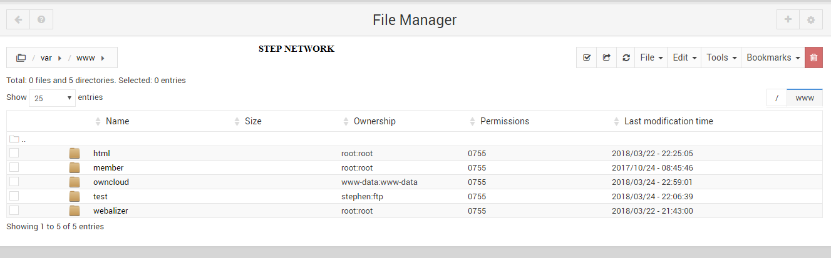

**SETTING UP VIRTUAL HOST**

Click on **Servers** => **Apache webserver**

Click on ‘**create virtual host’** tab

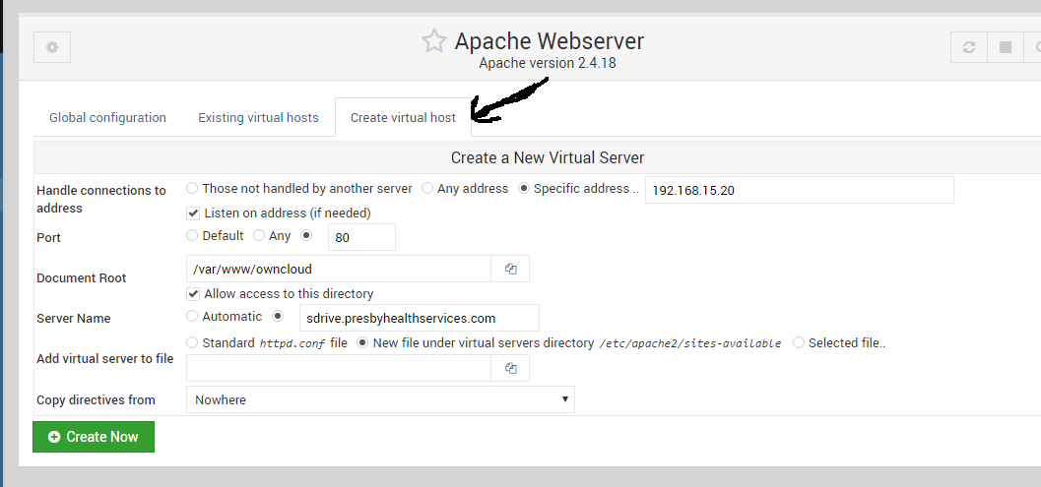

Enter the following fields:

**Handle connections to**: select: Specific Address and enter the server’s IP

**Port**: Enter port 80

**Document Root**: This is where site files are stored. Use for eg: /var/www/owncloud

**Server Name**: your domain. Example. sdrive.snetgh.net

**Add virtual server to file**: (leave default as Standard httpd.conf file)

**Copy directives from**: (leave default: Nowhere)

Click create now.

Add a Server alias for domain www.sdrive.snetgh.net

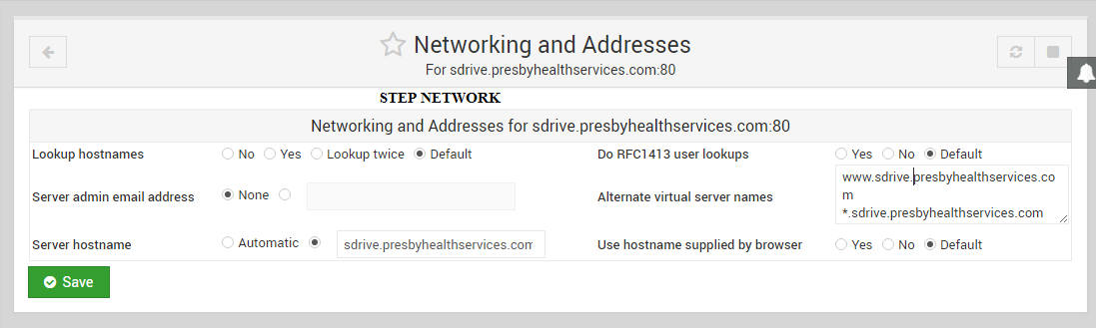Click on Servers => **Apache Web Server** => **Existing Virtual Hosts**

Click on the virtual server you just created and Click on “**Networking and Addresses**”

Add any other server aliases to use in ‘**Alternate Virtual Server Names’** box

Type in the space: **www.sdrive.snetgh.net** and **\*. sdrive.snetgh.net** and Click Save.

Click on ‘**Apply changes’**. This will save the configuration and restart Apache.

**HOW TO INSTALL LET’S ENCRYPT WITH APACHE**

Let’s Encrypt is an open SSL Certificate Authority (CA) that offers free domain-validated (DV) certificates for your websites. SSL Certificates are used to establish a secure encrypted connection between a web server and a user’s web browser. The SSL certificates that have been issued by Let’s Encrypt are valid for 90 days and are trusted by most web browsers today.

You need a registered domain name with its A record pointing to your server’s IP address.

**Install CertBot**

root@snet[~]# sudo nano /etc/apt/sources.list

root@snet[~]# deb http://deb.debian.org/debian stretch-backports main

root@snet[~]# sudo apt-get update

root@snet[~]# sudo apt-get install certbot python-certbot-apache -t stretch-backports

**Install Let’s Encrypt SSL**

root@snet[~]# sudo certbot --apache

**Renew the SSL certificate**

root@snet[~]# sudo certbot renew --dry-run

**INSTALLATION OF OWNCLOUD SERVER**

root@snet[~]# cd /var/www

root@snet[~]# wget <https://download.owncloud.org/community/owncloud-10.0.10.zip>

root@snet[~]# unzip owncloud-10.0.10.zip

root@snet[~]# sudo chown -R www-data:www-data /var/www/owncloud

**HOW TO ADD NEW DRIVE FOR OWNCLOUD DATA STORAGE**

root@snet[~]# sudo fdisk -l

root@snet[~]# sudo fdisk /dev/sdb

Press m

Press n

Press p

Press 1

Choose default

Choose default

Press p

Press w

root@snet[~]# df -h

root@snet[~]# mkfs.ext4 -b 4096 /dev/sdb

root@snet[~]# sudo nano /etc/fstab

Add below to fstab

/dev/sdb /sdrive ext4 defaults 0 0

root@snet[~]# cat /etc/fstab

root@snet[~]# mkdir -p /sdrive

root@snet[~]# mount /dev/sdb /sdrive

root@snet[~]# df -h

Grant www-data permissions to the sdrive so that owncloud can read the files

root@snet[~]# sudo chown -R www-data:www-data /sdrive

**FINAL CONFIGURATION**

Now, if you go to your domain name **sdrive.snetgh.net** in your browser, you will see a page that looks like this:

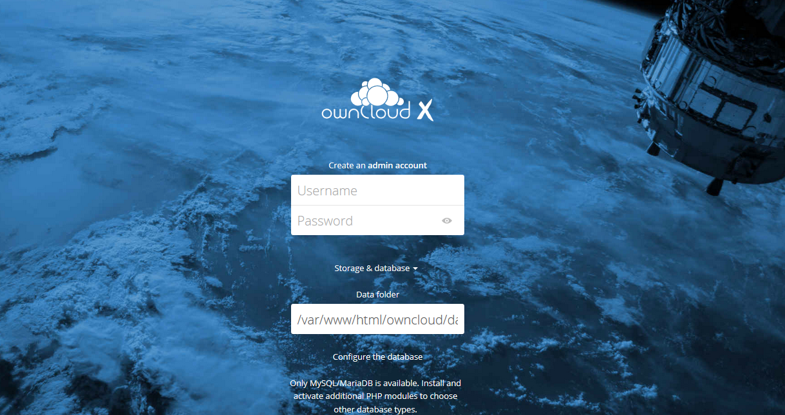

Create an admin account by choosing a username and a password. For security purposes it is not recommended to use something like "admin" for the username.

Before clicking the Finish setup button, change the data Storage to the external drive configured above.

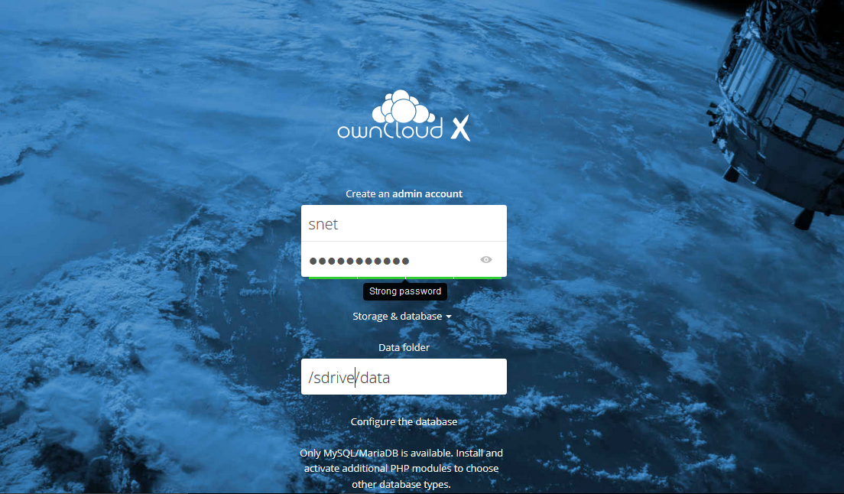

Enter the database information that you configured in the previous step. Below is an example, which matches the database credentials that we used in this guide:

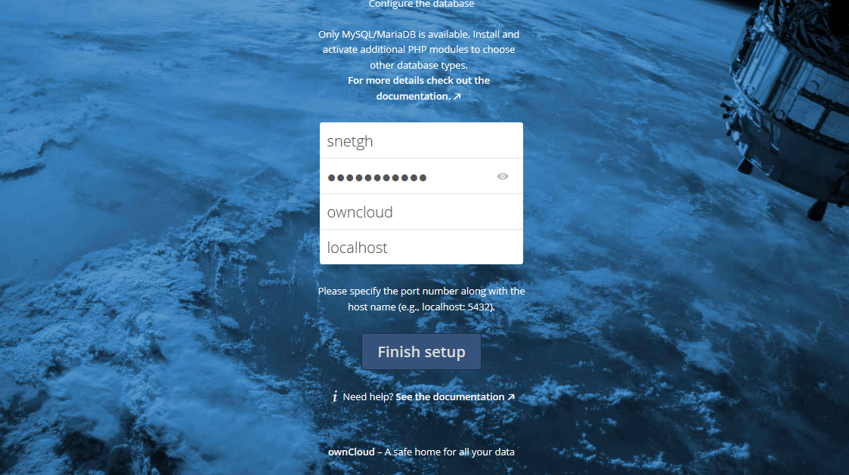

Click the Finish setup button to sign into OwnCloud. A safe home for all your data splash screen should appear:

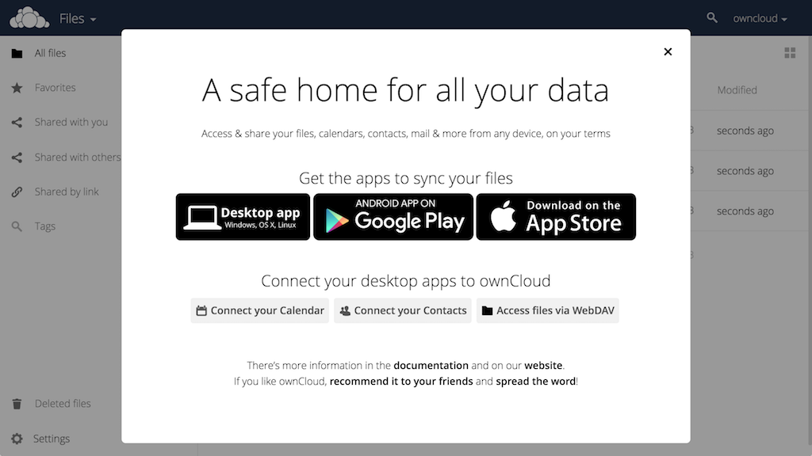

Click the x in the top-right corner of the splash screen to access the main interface:

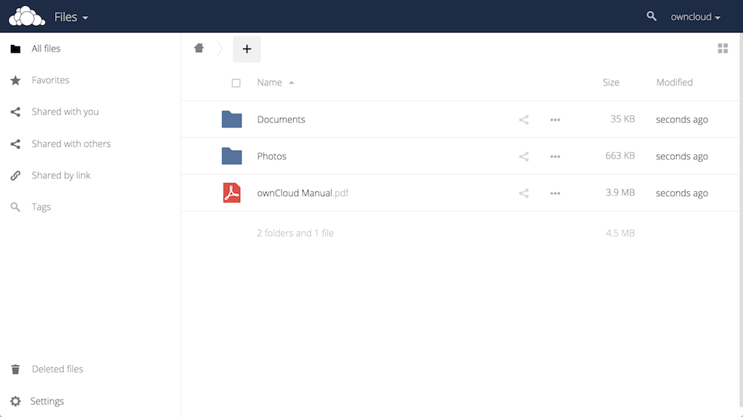

Here, you can create or upload files to your personal cloud.

**MEMORY CACHE SETUP IN OWNCLOUD**

root@snet[~]# nano /var/www/owncloud/config/config.php

*Type the following line of text to the config.php at the top*

'memcache.local' => '\OC\Memcache\Redis',

'memcache.locking' => '\\OC\\Memcache\\Redis',

'redis' => array(

'host' => 'localhost',

'port' => 6379,

),

**HOW TO DISABLE CODE INTEGRITY CHECK AND HELP IN OWNCLOUD**

root@snet[~]# nano /var/www/html/owncloud/config/config.php

Go to the end of file and add the following line before the line with)**;** and insert

**'integrity.check.disabled' => true,**

**'knowledgebaseenabled' => false,**

Now you can login as an admin into your OwnCloud and if you still see the message "There are problems with the code integrity check. More information ..." go to the Admin Page.  
There you can click the link Rescan.

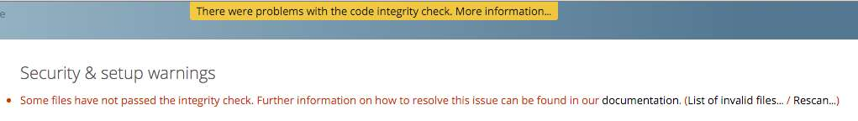

**HOW TO CONFIGURE STRICT TRANSPORT SECURITY (HSTS)**

**STRICT TRANSPORT SECURITY**

root@snet[~]# nano /etc/apache2/sites-available/owncloud-ssl.conf

*Add the following snippet of code to the SSL.conf file*

**Header always add Strict-Transport-Security "max-age=15768000; includeSubDomains; preload"**

root@snet[~]# a2enmod headers

root@snet[~]# sudo service apache2 restart

**DEPLOYING PYTHON-DJANGO APPLICATION**

root@snet[~]# sudo apt-get install python3-pip

root@snet[~]# sudo apt-get install python3-venv

root@snet[~]# sudo apt-get install python-pip python-dev mariadb-server libmariadbclient-dev libssl-dev

**CREATE DJANGO VIRTUAL ENVIRONMENT**

root@snet[~]# python3 -m venv /var/www/member/venv

**ACTIVATING OF DJANGO VIRTUAL ENVIRONMENT**

Make sure you are in member folder

root@snet[~]# cd /var/www/member

root@snet[~]# source venv/bin/activate

(venv) root@snet[~]# pip install django mysqlclient

(venv) root@snet[~]# sudo apt-get install libapache2-mod-wsgi-py3

(venv) root@snet[~]# pip install -r requirements.txt

**ADDING HOST NAME/ IP IN DJANGO PROJECT**

(venv) root@snet[~]# sudo nano member/setting.py

Look for Allowed_Host=[‘hostname’,’IP’] and the Hostname/IP

Look for STATIC_URL and add below on top of it.

STATIC_ROOT = ‘project_name/staticfolder

Save ctrl+o enter and ctrl+x to exit

**RUN STATIC ON THE SERVER**

(venv) root@snet[~]# python manage.py collectstatic

**RUN PYTHON DEVELOPMENT SERVER FOR PUBLIC ACCESS**

(venv) root@snet[~]# python manage.py runserver 0.0.0.0:8000

**CONNECT MYSQL AND DJANGO**

Create database using console command line or phpmyadmin shown above

In member folder create a file call mysql.cnf and add the following

[client]

database = DB_NAME

host = localhost # Or an IP Address that your DB is hosted on

user = DB_USER

password = DB_PASSWORD

default-character-set = utf8

**RESTART MYSQL**

(venv) root@snet[~]# sudo systemctl restart mysql

**SETTING DJANGO UP TO USE MYSQL**

(venv) root@snet[~]# sudo nano (foldercontainingsetting)/setting.py

Look for Database and comment the default database connection

Add the following to settings.py

DATABASES = {

'default': {

'ENGINE': 'django.db.backends.mysql',

'NAME': 'DB_NAME',

'USER': 'DB_USER',

'PASSWORD': 'DB_PASSWORD',

'HOST': 'localhost', # Or an IP Address that your DB is hosted on

'PORT': '3306',

}

}

**CHECK DJANGO, CREATE SUPERUSER, MAKE MIGRATIONS, RUNSERVER**

(venv) root@snet[~]# python manage.py check

(venv) root@snet[~]# python manage.py migrate

(venv) root@snet[~]# python manage.py makemigrations

(venv) root@snet[~]# python manage.py migrate

(venv) root@snet[~]# python manage.py createsuperuser

(venv) root@snet[~]# python manage.py runserver 0.0.0.0:8000

**USE DJANGO WITH APACHE AND MOD_WSGI**

**Create a vhost in apache2 and edit using webmin as shown above**

<VirtualHost 192.168.15.18:80>

DocumentRoot /var/www/member

ServerName rasp.presbyhealthservices.com

<Directory "/var/www/member">

Allowoverride All

</Directory>

ServerAlias www.rasp.presbyhealthservices.com .*rasp.presbyhealthservices.com

Alias /static /var/www/member/static

<Directory /var/www/member/static>

Require all granted

</Directory>

#Alias /media /var/www/django/media

#<Directory /var/www/django/media>

# Require all granted

#</Directory>

<Directory /var/www/member/member>

<Files wsgi.py>

Require all granted

</Files>

</Directory>

WSGIScriptAlias / /var/www/member/member/wsgi.py

WSGIDaemonProcess member python-path=/var/www/member python-home=/var/www/member/venv

WSGIProcessGroup member

</VirtualHost>

Restart Apache2 for changes to take effect

(venv) root@snet[~]# sudo service apache2 restart

***BY STEPHEN FOSU***

***31ST*** MARCH, 2019